Project Development Phase Sprint-1 Test Cases

|  |  |
| --- | --- |
| Date | 1 November 2022 |
| Team ID | PNT2022TMID2564 |
| Project Name | Virtual Eye - Life Guard For Swimming Pools To  Detect Active Drowning |
| Maximum Marks | 8 Marks |

Login Page:

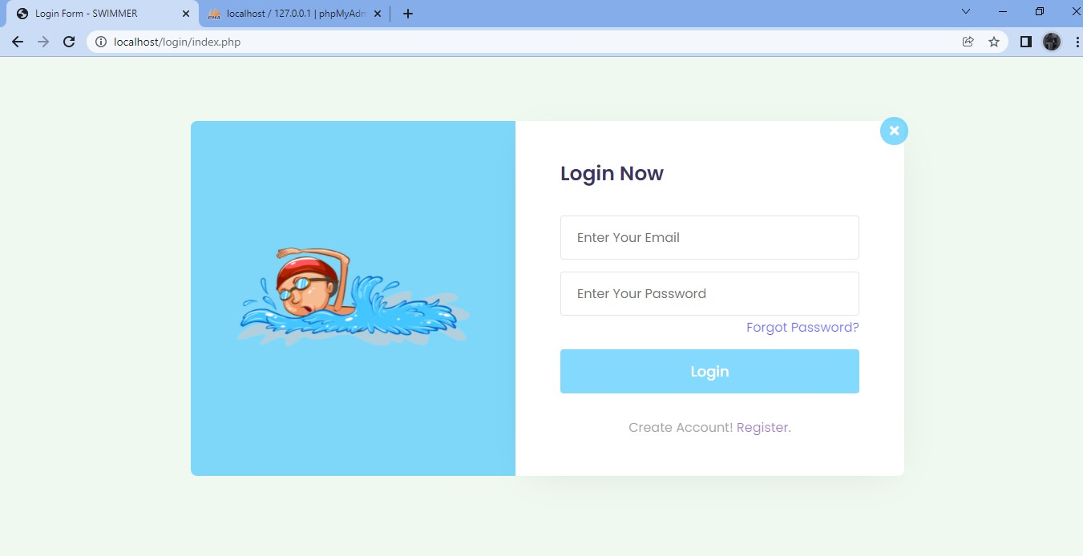

Register page:

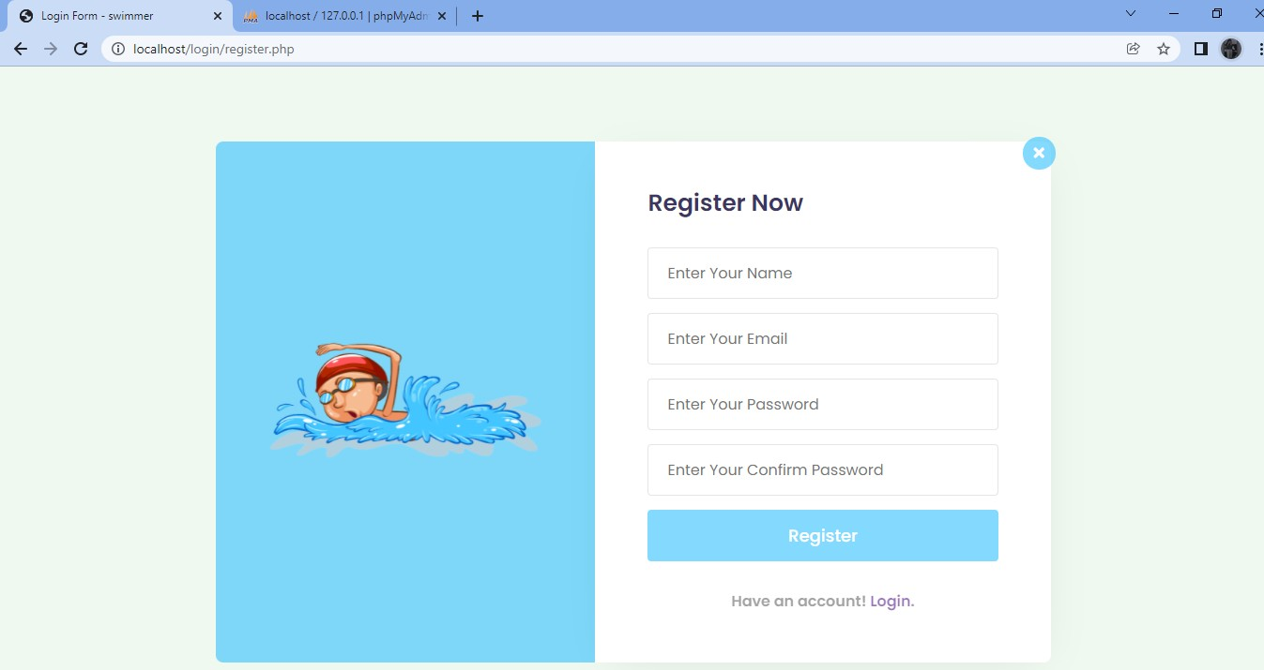

User Conformation:

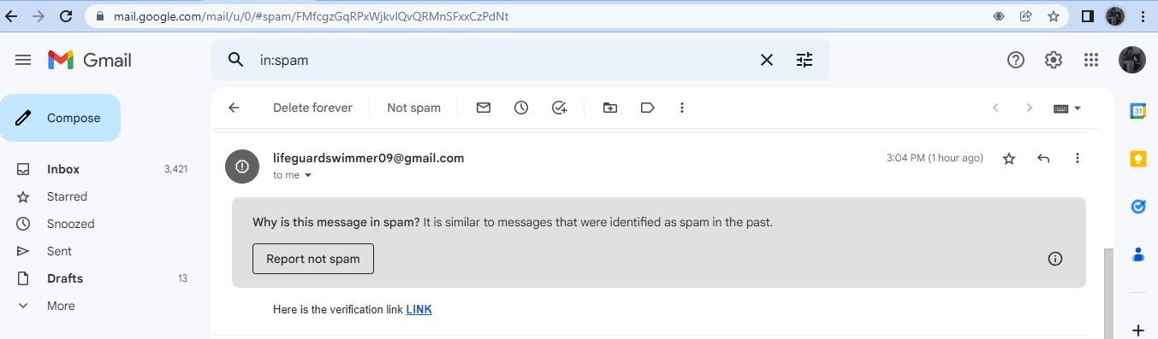

Forgot password:

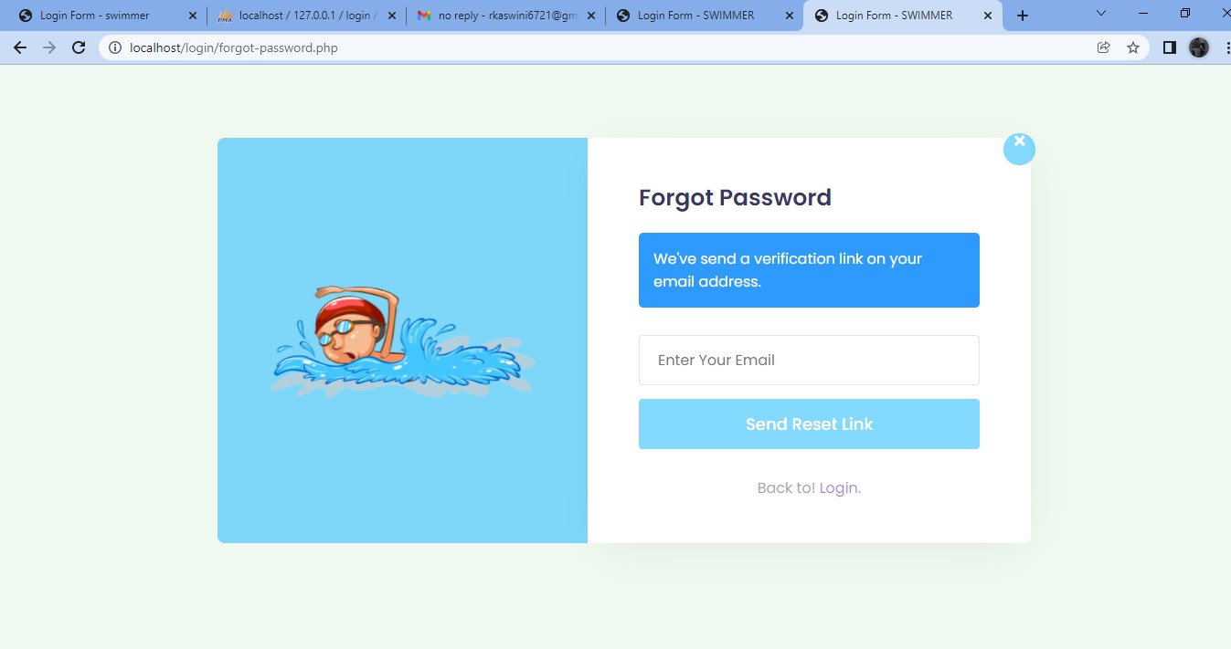

Reset password:

